**IT8761 – Security Laboratory**

**Reshma Ramesh Babu**

**312217104129**

**Exercise 11**

**Aim:** To download the N-Stalker Vulnerability Assessment Tool and exploring the features.

Step 1: Install the free version of n-stalker

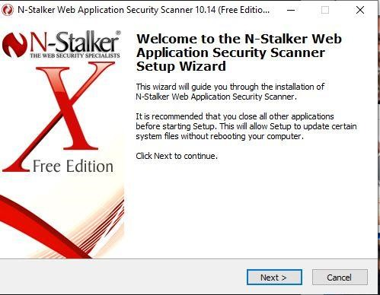

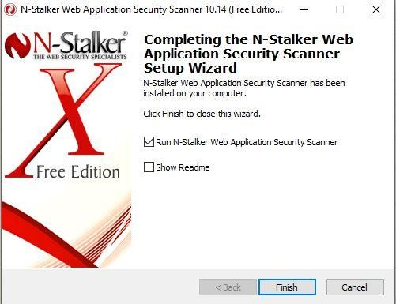

Step 2: Run and update n-stalker

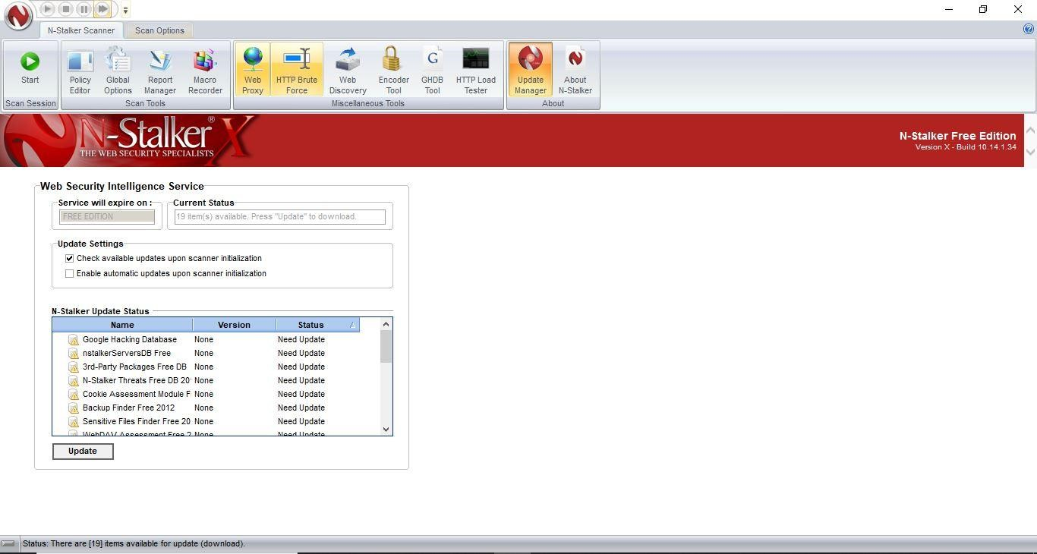

Step 3: Enter a host address or a range of addresses to scan and click “start ScanWizard”

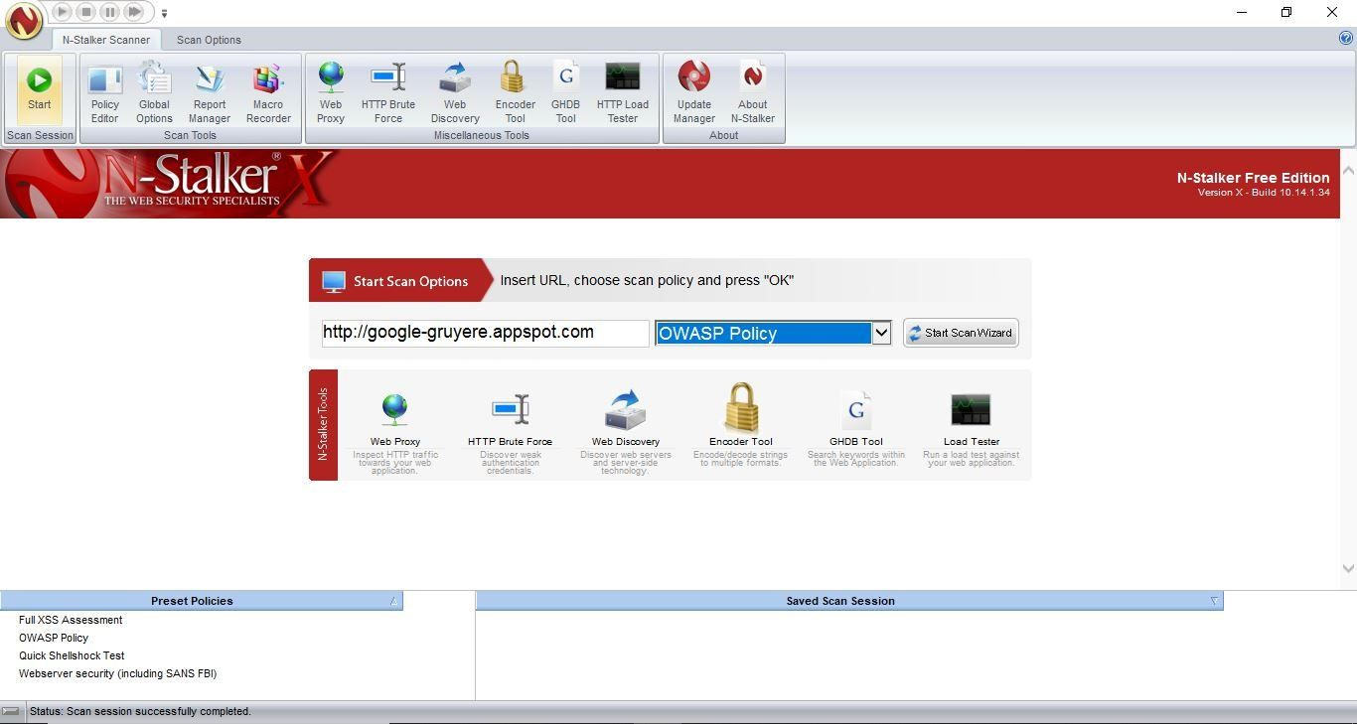

Step 4: A prompt appears. In scan policy, you can select from the four options,

* Manual test which will crawl the website and will be waiting for manual attacks.
* full xss assessment
* owasp policy
* Web server infrastructure analysis.

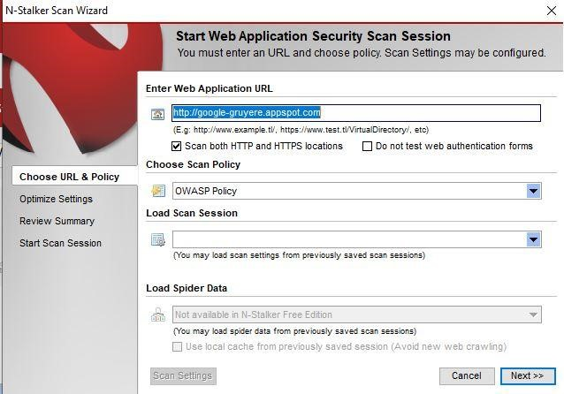

Step 5: Once, the option has been selected, next step is “Optimize settings” which will crawl the whole website for further analysis.

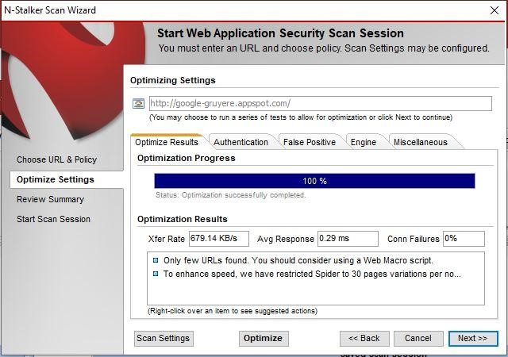

Step 6: In the engine option, you can choose certain supported server side technologies, if you know the backend of the server.

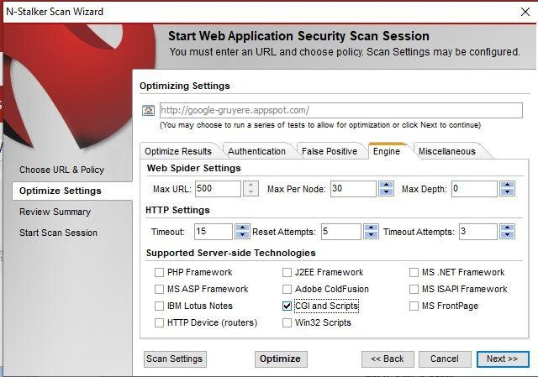

Step 7: In review option, you can get all the information like host information, technologies used, policy name, etc.

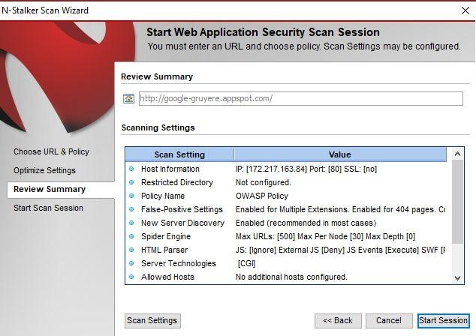

Step 8: Once done, start the session and start the scan. The scanner will crawl the whole website and will show the scripts, broken pages, hidden fields, information leakage, web forms related information which helps to analyze further.

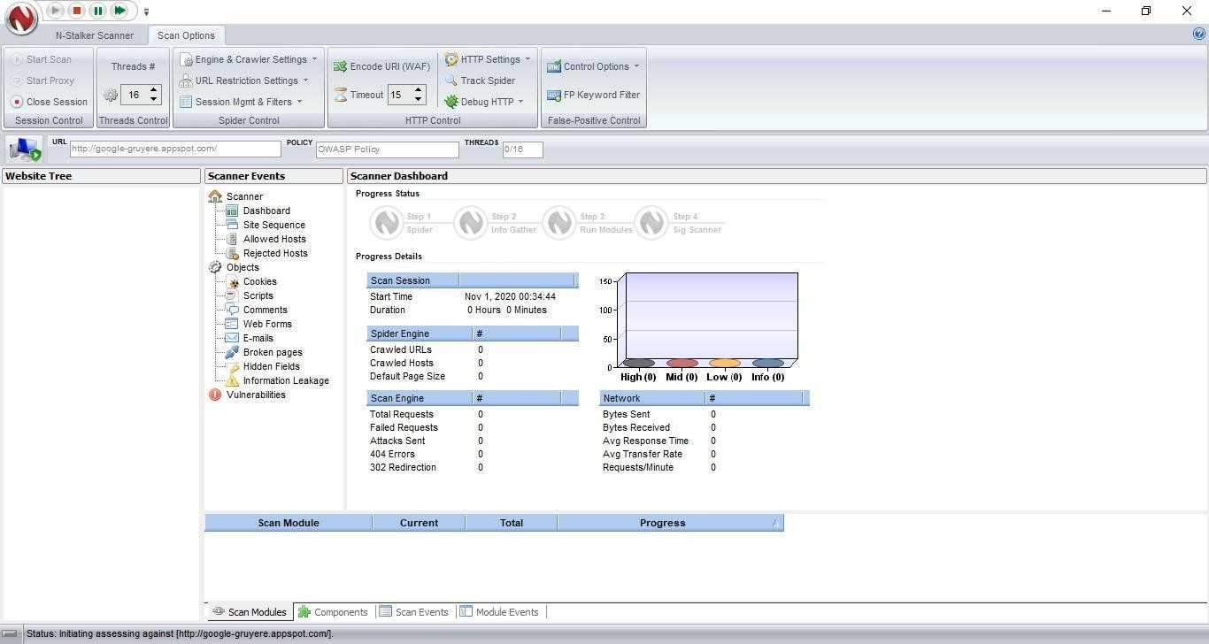

Step 9: Once the scan is completed, the NStalker scanner will show details like severity level, vulnerability class, why is it an issue, the fix for the issue and the URL which is vulnerable to the particular vulnerability.

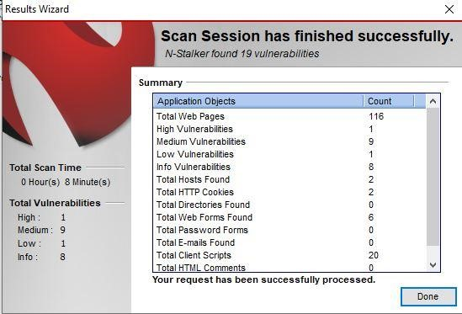

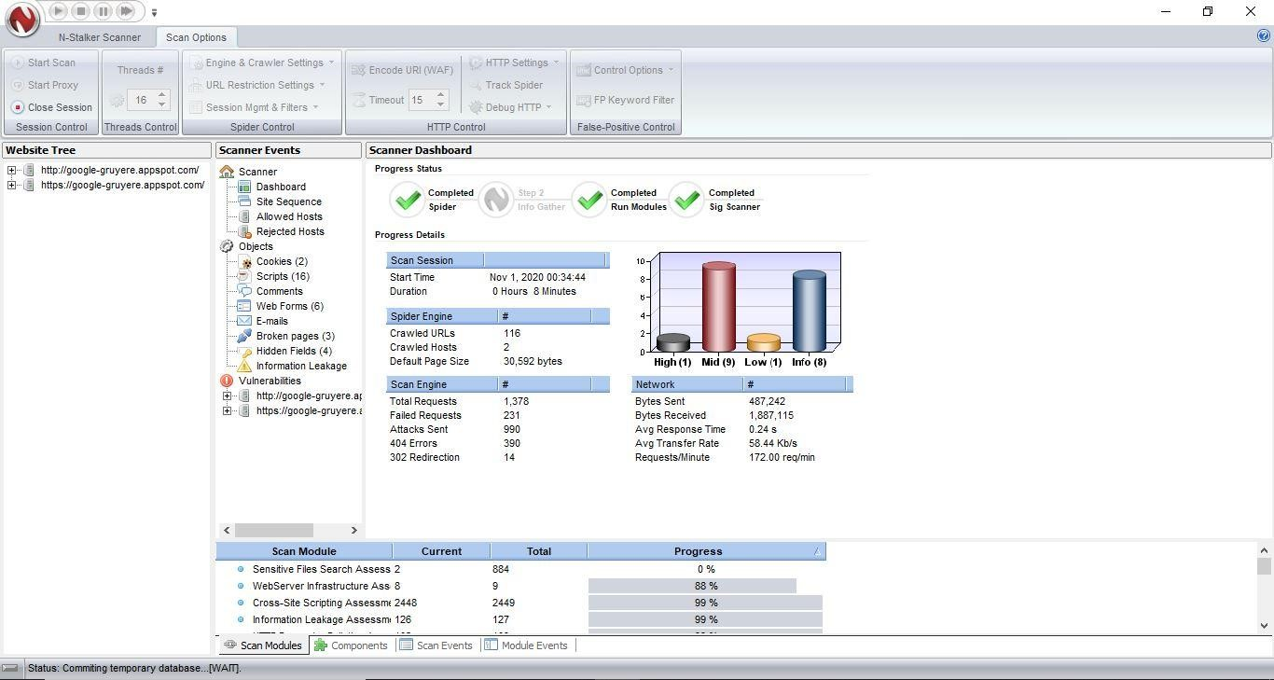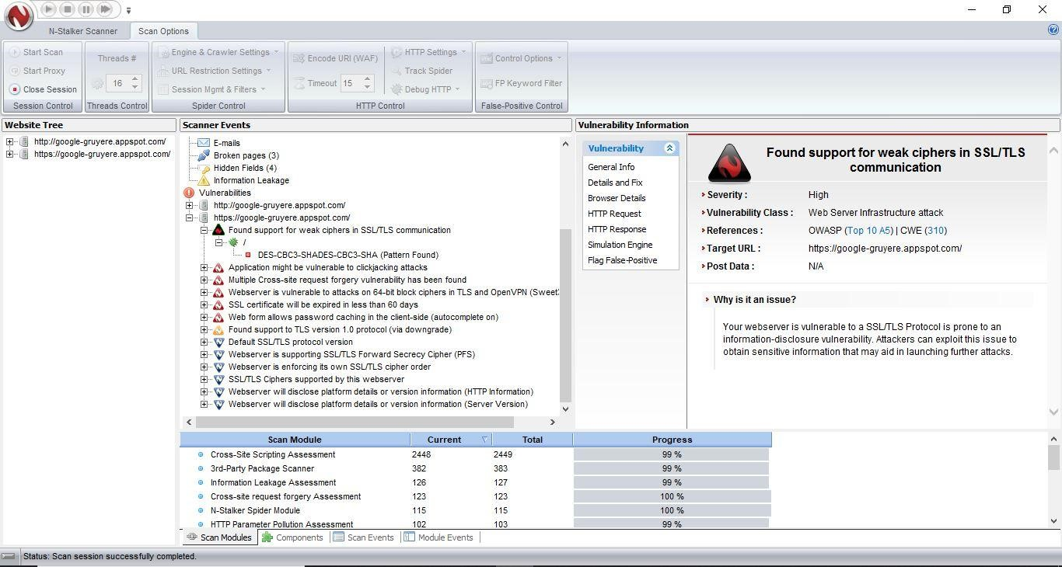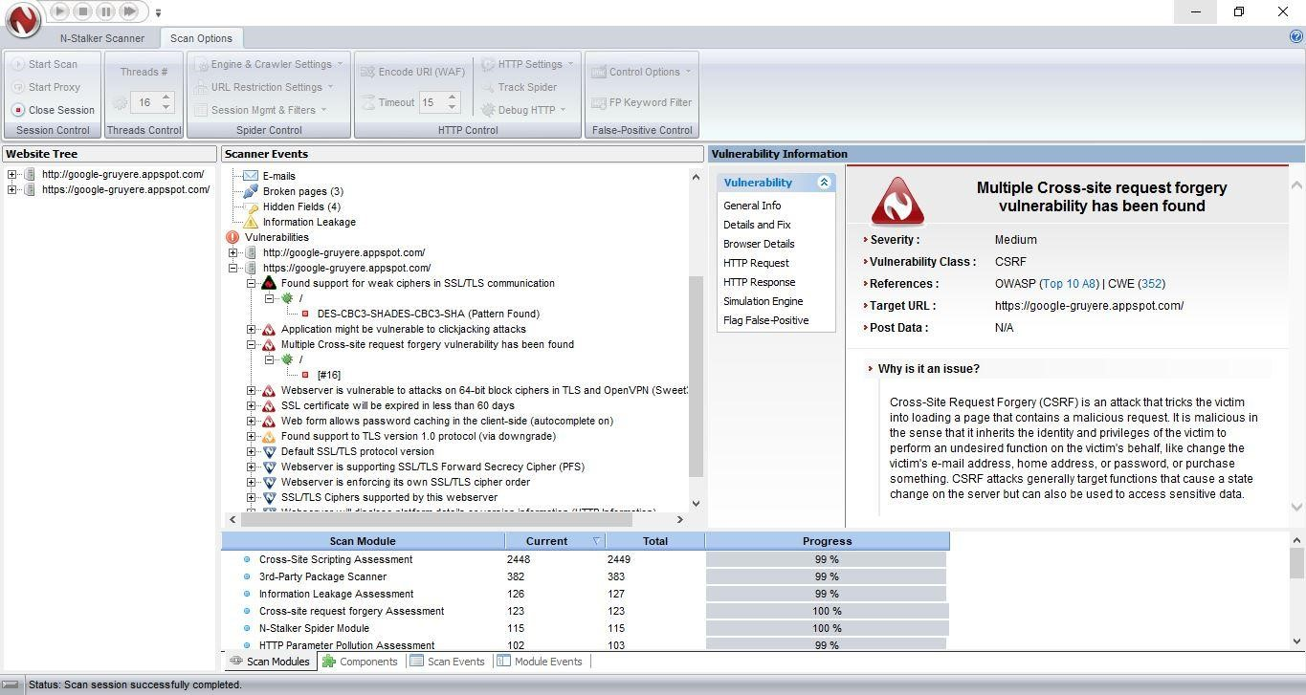

Step 10: Go to Report Manager, click on saved scan, generate either an executive/technical report

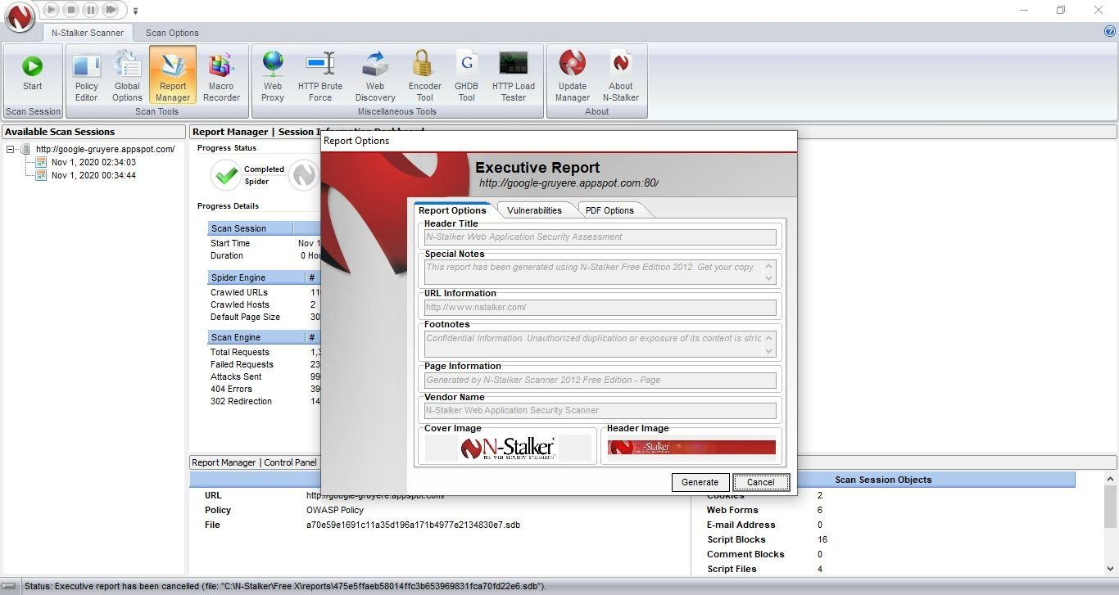

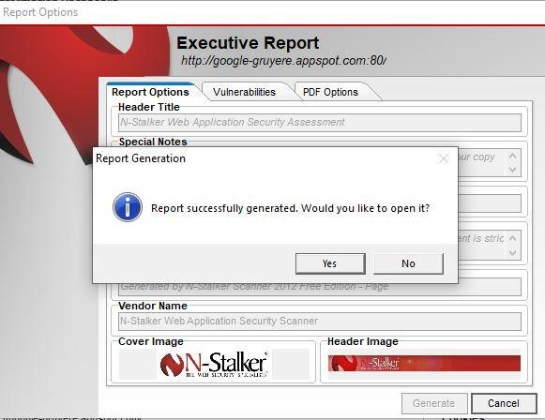

Step 11:View the saved report.

